The Genetics of Sickle Cell Anemia and Sickle Cell Trait
– How One Gene Affects Multiple Characteristics

How can one gene affect so many different characteristics?
In this activity, you will analyze the effects of two alleles of the hemoglobin gene. Hemoglobin is the protein in red blood cells that carries oxygen.
- The H allele provides the instructions for making normal hemoglobin.
- The h allele provides the instructions for making sickle cell hemoglobin.

This table shows the effects of these two alleles.

Genotype | Phenotype (characteristics)
HH | Normal health – If red blood cells are infected with the malaria parasite, the person generally has more severe malaria.
Hh | Sickle cell trait – Generally normal health – If red blood cells are infected with the malaria parasite, the person generally has less severe malaria.
hh | Sickle cell anemia – Episodes of severe pain – Damage to body organs – Anemia (not enough red blood cells, which results in a feeling of low energy)

1a. Describe the advantage of being heterozygous for the sickle cell hemoglobin allele (Hh), instead of homozygous for the normal hemoglobin allele (HH).

1b. Describe the advantages of being heterozygous for the sickle cell hemoglobin allele (Hh), instead of homozygous for the sickle cell hemoglobin allele (hh).

To understand how two alleles of a single gene can affect all these different characteristics, you need to understand the molecular and cellular effects of these alleles of the hemoglobin gene.

Normal hemoglobin dissolves in the watery cytosol of the red blood cell. Red blood cells with normal hemoglobin are disk-shaped and flexible, so they can squeeze through the smallest blood vessels (Figure A). | 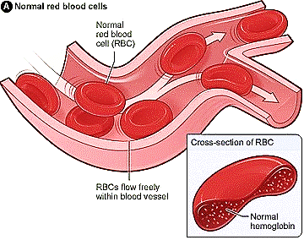

Sickle cell hemoglobin can cause red blood cells to change shape.

Genotype | → | Protein |  | → | Red Blood Cells
HH  (or Hh) | → | Normal hemoglobin (or mixture of normal and sickle cell hemoglobin) dissolves in the cytosol of red blood cells. |  | → | Disk-shaped and flexible
hh | → | When oxygen levels are low, sickle cell hemoglobin tends to clump in long rods inside red blood cells. |  | → | Sickle-shaped (banana-shaped) and rigid

When sickle cell hemoglobin clumps in long rods, the red blood cells are shaped like a sickle or banana. These sickled cells can block blood flow through smaller blood vessels (Figure B). Blocked blood flow cuts off the oxygen supply, which causes episodes of severe pain and damages body organs.

In addition, there is another, more chronic effect of the hh genotype. Red blood cells that have been stressed by repeated episodes of sickling do not survive as long as normal red blood cells.
The bone marrow can’t replace the dying red blood cells fast enough to maintain a normal level of red blood cells. When a person doesn’t have enough red blood cells, this is called anemia. Anemia results in a reduced oxygen supply to the body’s cells, so the person often feels tired.

2a. To prepare to complete the flowchart shown below, review the information on this page. Underline key points that explain the molecular, cellular and health effects of the hh genotype.

2b. Complete this flowchart by filling in each intermediate step that describes how the hh genotype can cause pain, damage to body organs, and anemia.

A person with sickle cell trait has the Hh genotype, so each red blood cell has roughly half normal hemoglobin and half sickle cell hemoglobin. The normal hemoglobin in the red blood cells prevents the sickle cell hemoglobin from forming long rods. As a result, a person with sickle cell trait almost never experiences the pain, organ damage, and anemia that occur in sickle cell anemia.

3a. A person who is heterozygous for a dominant-recessive pair of alleles has the same

phenotype as a person who is homozygous for the ___________________ allele.
(dominant / recessive)

3b. What evidence supports the claim that the H allele is dominant and the h allele is recessive?

Although the H allele is often described as dominant, there is an important difference between the phenotypes of heterozygous Hh people and homozygous HH people. Specifically, heterozygous Hh people are less likely to develop severe malaria. Malaria is caused by a parasite that grows in red blood cells, and the malaria parasite doesn’t reproduce as well in red blood cells that have some sickle cell hemoglobin.

4. Complete this chart to describe how each allele in a heterozygous Hh person influences his or her phenotype (characteristics).

Allele | → | Protein | → | How this Protein Affects the Hh Phenotype
H | → |  | →
h | → |  | →

To review and learn more, watch the video, “How This Disease Changes the Shape of Your Cells” (https://www.youtube.com/watch?v=hRnrIpUMyZQ).

Inheritance of the Sickle Cell Allele

5. Near the end of the video, the narrator makes a distinction between the effects of inheriting a sickle cell allele from one parent vs. inheriting sickle cell alleles from both parents. Match each item in the top list with the best matches from the bottom list.

sickle cell allele inherited from one parent ___ ___

sickle cell allele inherited from both parents ___ ___

- sickle cell anemia
- sickle cell trait
- can be beneficial in areas where malaria is common
- has harmful health effects
6a. Draw a Punnett square for two parents who both have sickle cell trait (Hh).

6b. Explain how two parents who do not have sickle cell anemia can have a child with sickle cell anemia.

This pedigree chart shows the inheritance of sickle cell anemia in three generations of a family. Each male is symbolized by a square and each female is symbolized by a circle. A person who has sickle cell anemia is symbolized by a dark square or circle. The couple labeled 1 and 2 had five children, including one daughter with sickle cell anemia (5).

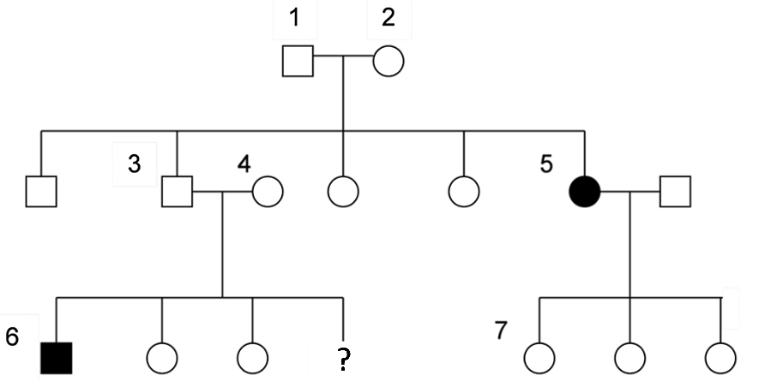

7a. In the pedigree, write the genotypes of each person who is labeled with a number.

7b. If parents 3 and 4 had a fourth child, what is the probability that this child would have sickle cell anemia? 0%___ 25% ___ 50% ___ 75%___ 100%___

7c. Explain your reasoning.

A model is a simplified representation of a complex biological process. A model does not include all of the features of the process it represents; instead, the model highlights certain key features of the process. For example, Punnett squares and pedigree charts provide different types of information about inheritance.

8a. Compare Punnett squares with pedigree charts. Describe an advantage of a Punnett Square as a model of inheritance.

8b. Describe an advantage of a pedigree chart as a model of inheritance.

By Dr. Ingrid Waldron, Dept. Biology, Univ. Pennsylvania, © 2022. This Student Handout and Teacher Notes (with instructional suggestions and background information) are available at https://serendipstudio.org/exchange/bioactivities/geneticsSCA.

